Infosys Springboard Virtual Internship 6.0 Completion Report

Team Details <Do not mention any personally identifiable information like email ID, institute details, mobile phone number etc.>
Batch Number 4
Start date 13/oct/2025
Names: <Gottapu Yamini >
Internship Duration: 8 Weeks

1. Project Title
NeuroFleetX AI-Driven Urban Mobility Optimization

2. Project Objective
The main objective of this internship project was to develop a web-based urban mobility management system to improve fleet operations, traffic monitoring, and route management. The project aimed to streamline urban transportation workflows, reduce operational inefficiencies, and provide real-time dashboards for city administrators and fleet operators. This system is relevant to organizations that manage city transportation or logistics, as it helps in decision-making and operational optimization.

3. Project description in detail
NeuroFleetX is an AI-powered urban mobility optimization system designed to enhance the efficiency of transportation networks in smart cities. It collects real-time data from vehicles, traffic sensors, and IoT devices to analyze traffic patterns and predict congestion. Using machine learning, the system provides dynamic route optimization, fleet management insights, and driver behavior analysis to reduce delays, fuel consumption, and operational costs. Overall, NeuroFleetX improves city mobility by offering safer, faster, and more sustainable urban transportation solutions.

4. Timeline Overview
Week | Activities Planned | Activities Completed
Week 1 | Requirement Analysis & Problem Understanding | Requirement Analysis & Problem Understanding
Week 2 | Research on AI Models & Data Collection | Research on AI Models & Data Collection
Week 3 | System Architecture & Module Design | System Architecture & Module Design
Week 4 | Backend Development | Backend Development
Week 5 | Model Development | Model Development
Week 6 | Frontend & Dashboard Development | Frontend & Dashboard Development
Week 7 | System Integration & Testing | System Integration & Testing
Week 8 | Final Review, Report & Deployment | Final Review, Report & Deployment

5a. Key Milestones
Milestone | Description | Date Achieved
Project Kickoff | Started project and requirement gathering | week 1
Prototype/First Draft | login page | week 2
Mid-Term Review | add more pages | week 4
Final Submission | connect backend frontend and database | week 7
Presentation | neurofleetx.ppt | week 8

5b. Project execution details
1.Requirement Analysis: Gathered data requirements for fleet management, traffic patterns, and system functionality.
2. Backend Development: Built Spring Boot REST APIs to handle fleet and traffic data.
3. Database Integration: Created MySQL schema to store historical and real-time data.
4. AI Model Integration: Integrated traffic prediction and route optimization algorithms.
5. Frontend Development: Developed React dashboard for visualization of traffic, routes, and fleet performance.
6. Integration & Testing: Combined backend, frontend, and AI modules; performed functional and performance testing.
7. Deployment: Deployed in a testing environment and generated reports.

6. Snapshots / Screenshots
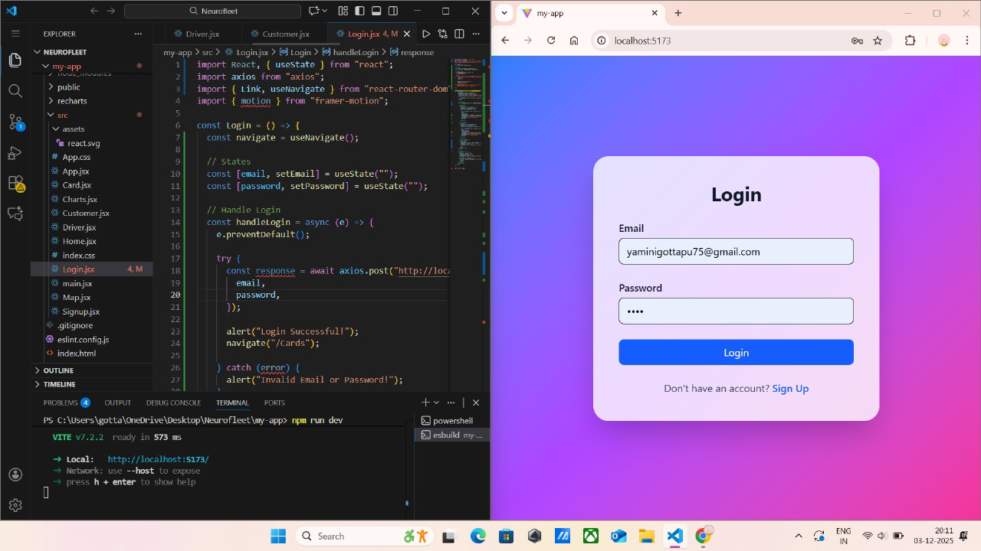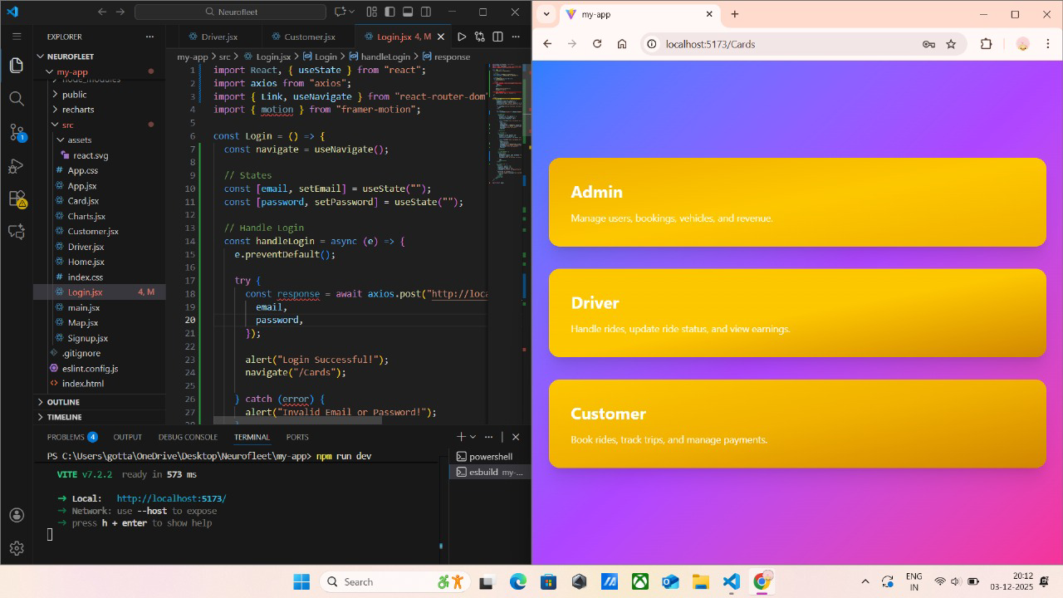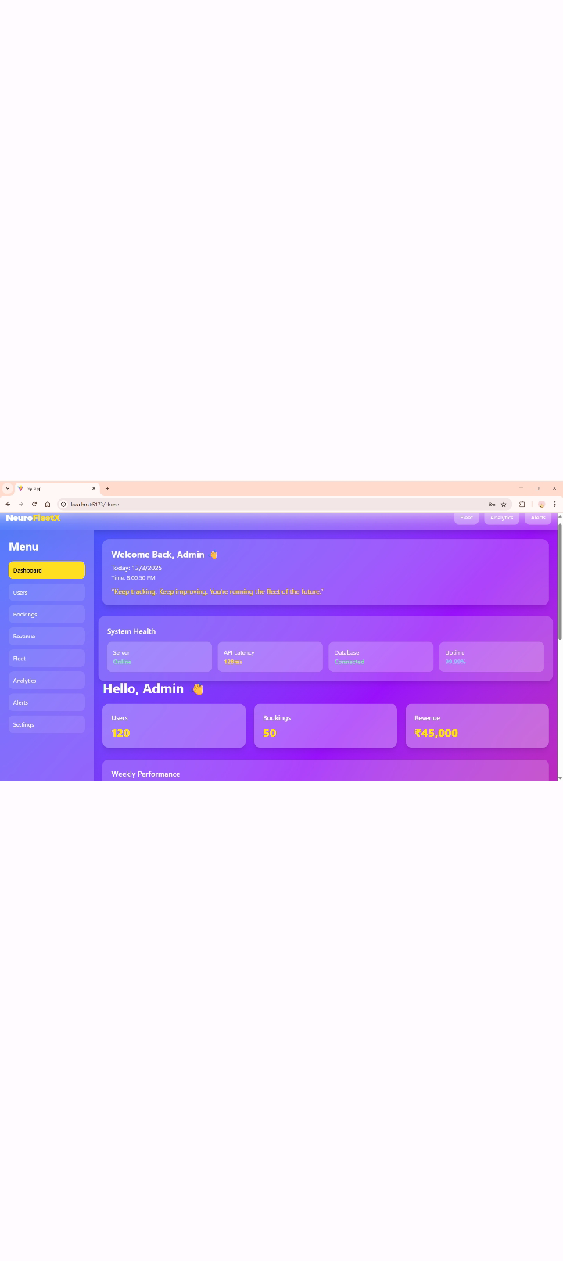

7. Challenges Faced
Data Availability: Limited real-time traffic data → Used simulated datasets.
Backend-Frontend Integration: Handling API responses in React → Implemented proper error handling and asynchronous calls.
Database Performance: Large datasets slowed queries → Optimized schema and indexes.

8. Learnings & Skills Acquired
Gained hands-on experience in React, Spring Boot, MySQL, and AI/ML integration.
Learned full-stack development, API development, data visualization, and predictive analytics.

9. Testimonials from team
This internship provided a real-world understanding of AI-driven mobility solutions. The project improved our technical and collaborative skills and strengthened practical knowledge of full-stack development.

10. Conclusion
The internship with NeuroFleetX allowed practical exposure to AI-driven urban mobility, full-stack development, and database management. It enhanced technical skills and understanding of smart city solutions, aligning with career goals in software development, AI, and data-driven urban planning.

11. Acknowledgements
We sincerely thank NeuroFleetX, our project mentor, and team members for their guidance, support, and encouragement throughout the internship.

